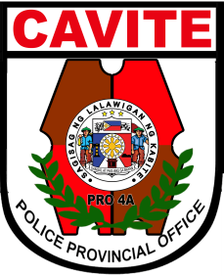Republic of the Philippines

National Police Commission

Philippine National Police

**Cavite Police Provincial Office**

**CARMONA MUNICIPAL POLICE STATION**

Brgy Maduya, Carmona, Cavite

***carmonacavitepnp@gmail.com***

March 8, 2022

**CERTIFICATE OF DETENTION**

**TO WHOM IT MAY CONCERN**

**THIS IS TO CERTIFY** that one **GARY MIRANDA**, male, 46 years old, married, resident of Sitio Davilan, Brgy. Lantic, Carmona, Cavite was detained at this office since December 16, 2021 up to present and charged for the crime of **“Murder”** with Criminal Case Nr. **B-2015-858,** before the Office of Fourth Judicial Region, Branch 89, Bacoor, Cavite.

This certification is being issued upon request of interested party for whatever legal purposes it may serve.

Prepared by :

**PSSg Percival Restrivera**

Custodial Officer